# **QUESTION 1: WHAT ARE THE DETAILS OF ALL CARS PURCHASED IN THE YEAR 2022?**

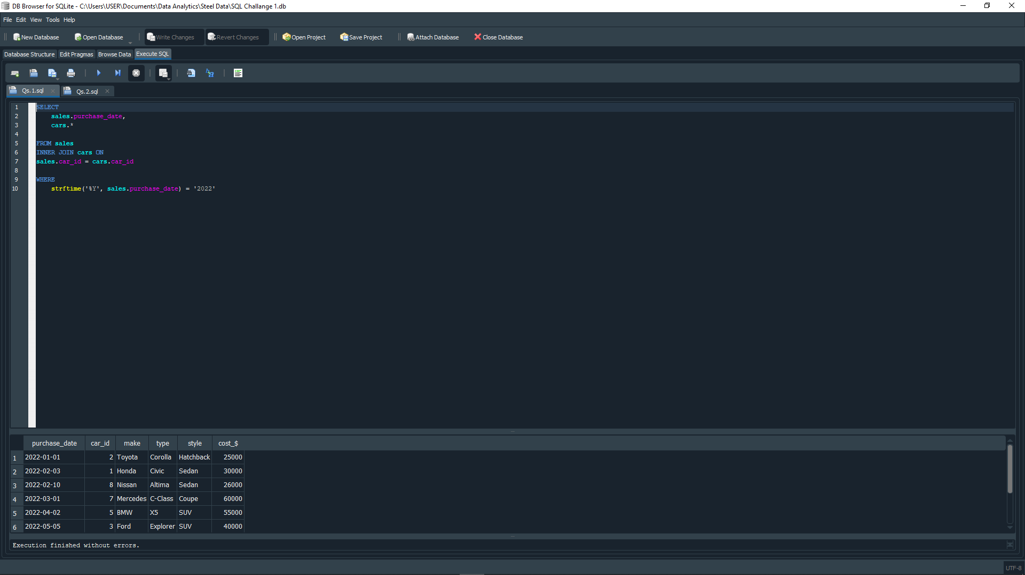

# **QUESTION 2: WHAT IS THE TOTAL NUMBER OF CARS SOLD BY EACH SALESPERSON?**

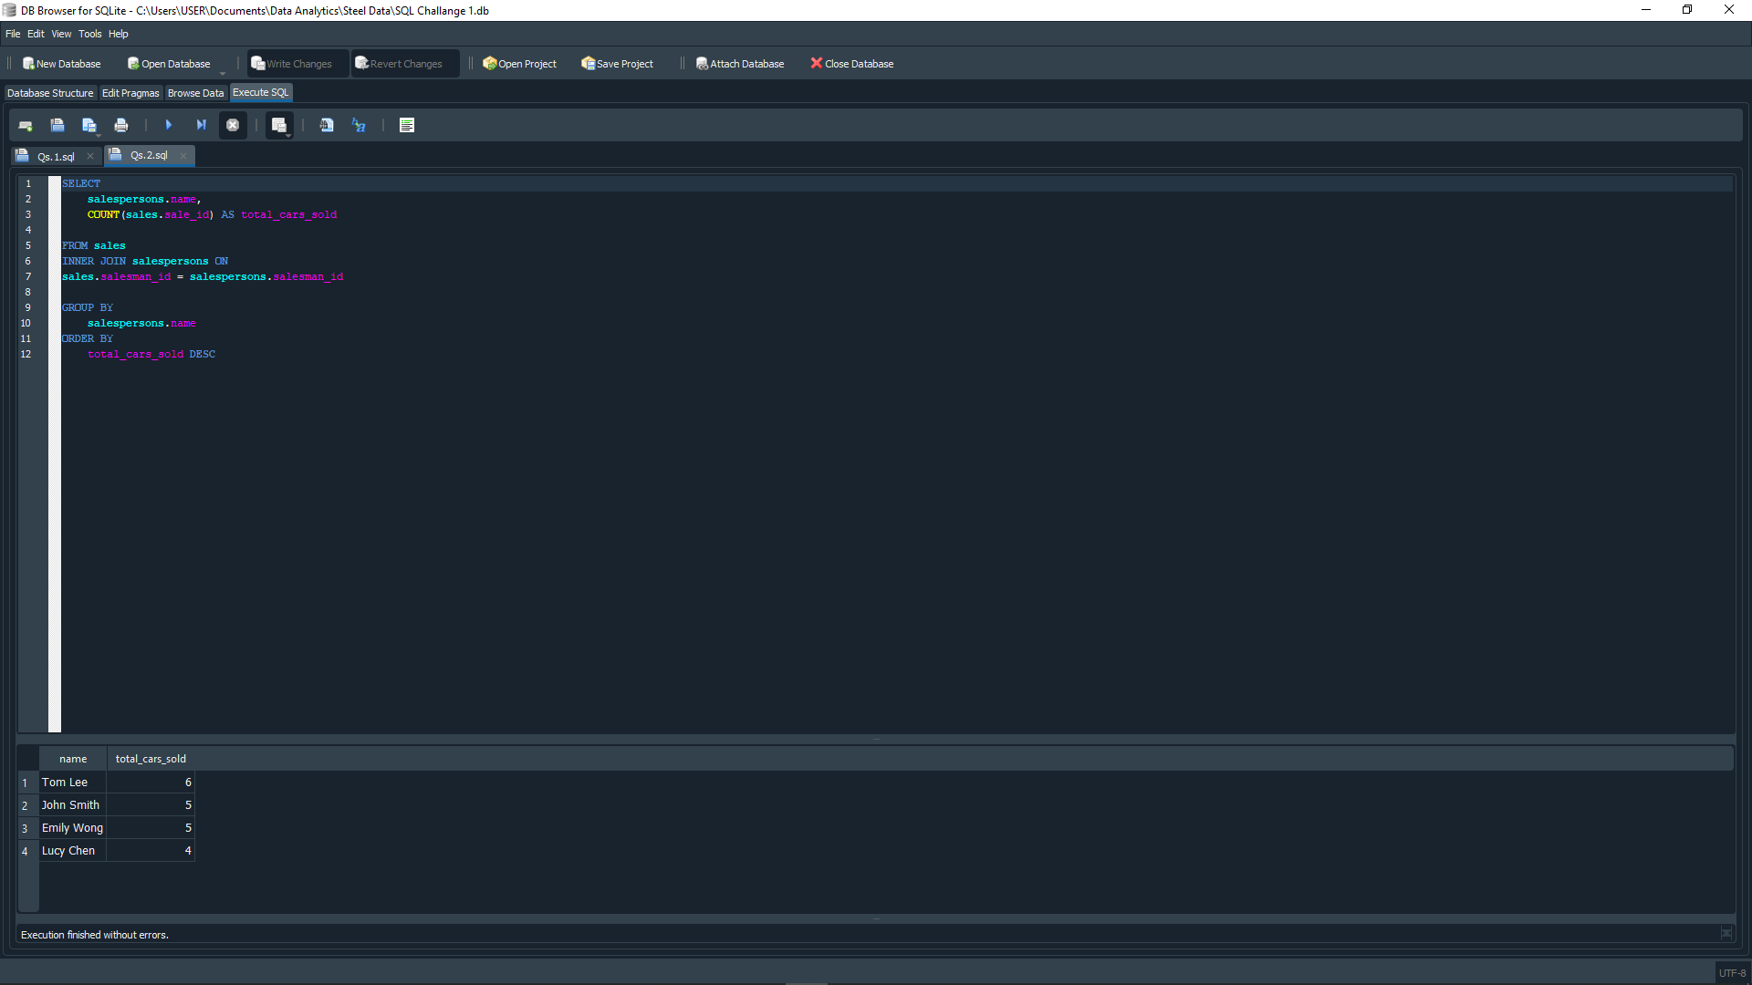

# **QUESTION 3: WHAT IS THE TOTAL REVENUE GENERATED BY EACH SALESPERSON?**



# **QUESTION 4: WHAT ARE THE DETAILS OF THE CARS SOLD BY EACH SALESPERSON?**

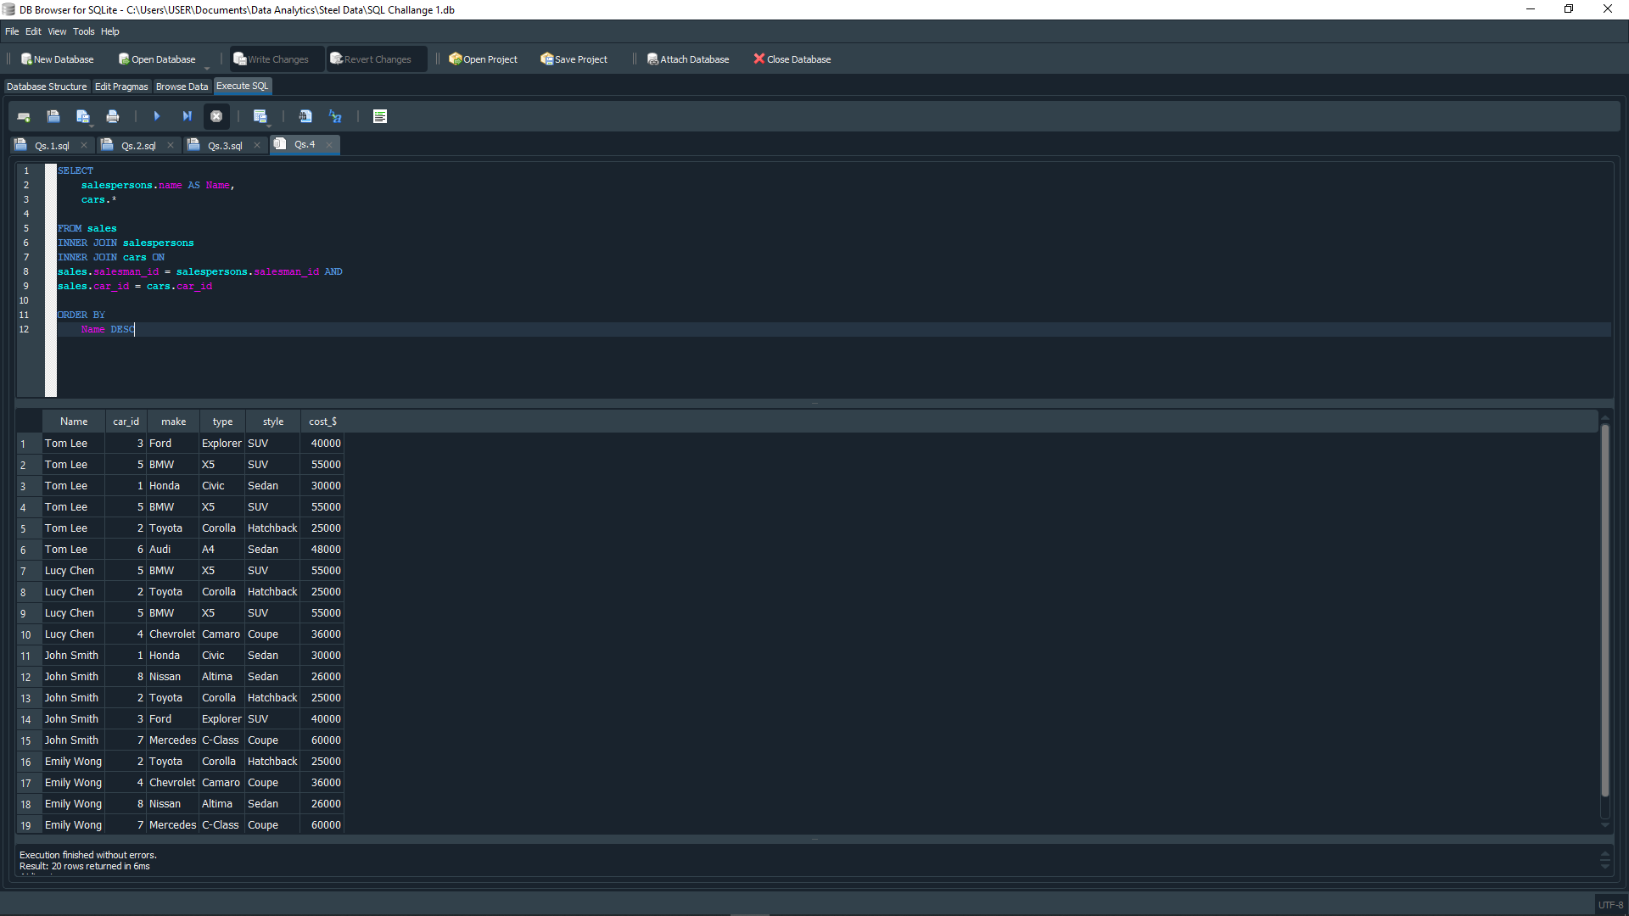

# **QUESTION 5: WHAT IS THE TOTAL REVENUE GENERATED BY EACH CAR TYPE?**

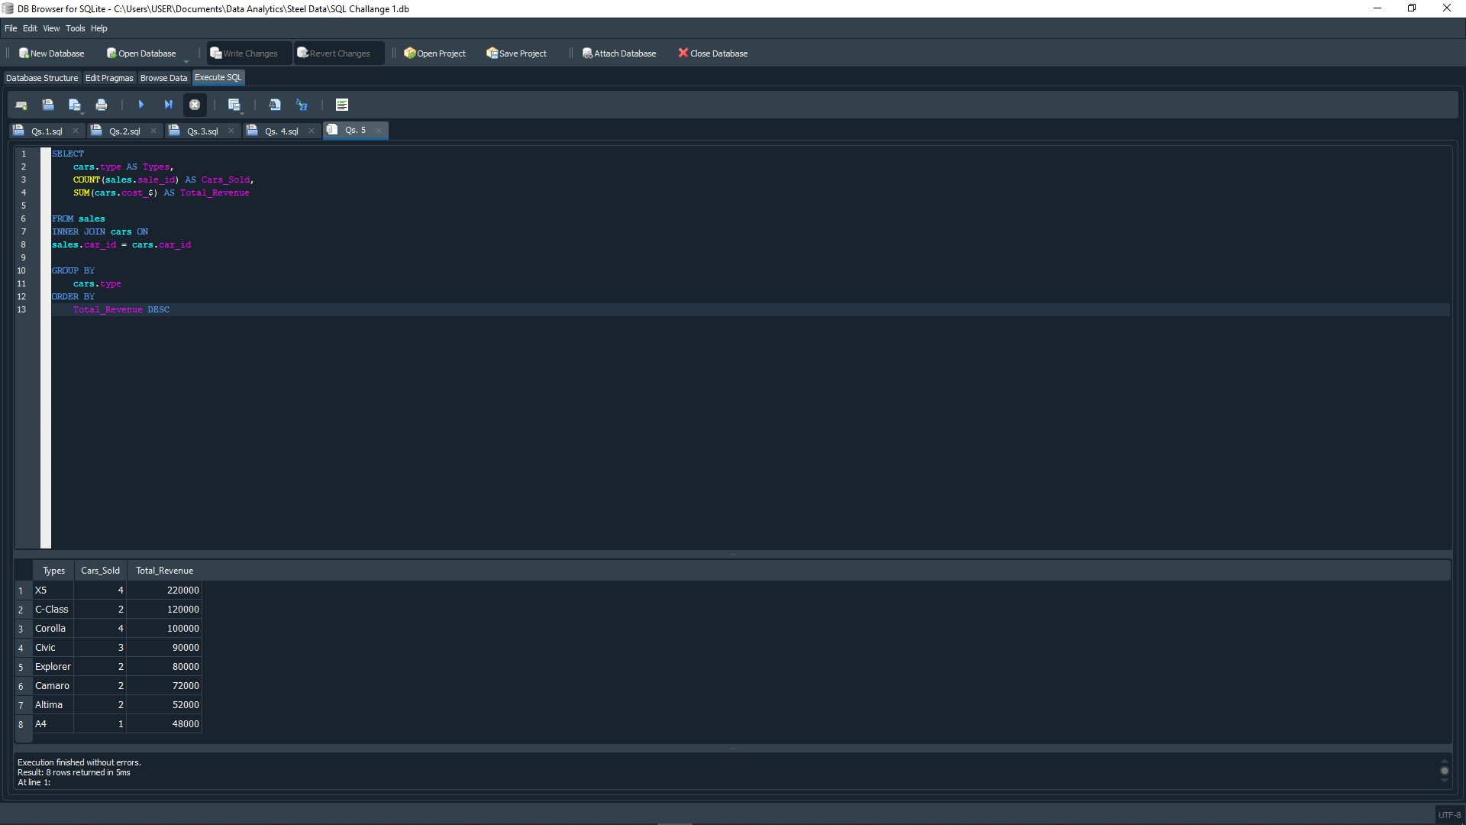

# **QUESTION 6: WHAT ARE THE DETAILS OF THE CARS SOLD IN THE YEAR 2021 BY SALESPERSON ‘EMILY WONG’?**



# **QUESTION 7: WHAT IS THE TOTAL REVENUE GENERATED BY SALES OF HATCHBACK CARS?**



# **QUESTION 8: WHAT IS THE TOTAL REVENUE GENERATED BY THE SALES OF SUV CARS IN THE YEAR 2022?**



# **QUESTION 9: WHAT IS THE NAME AND CITY OF THE SALESPERSON WHO SOLD THE MOST NUMBER OF CARS IN THE YEAR 2023?**

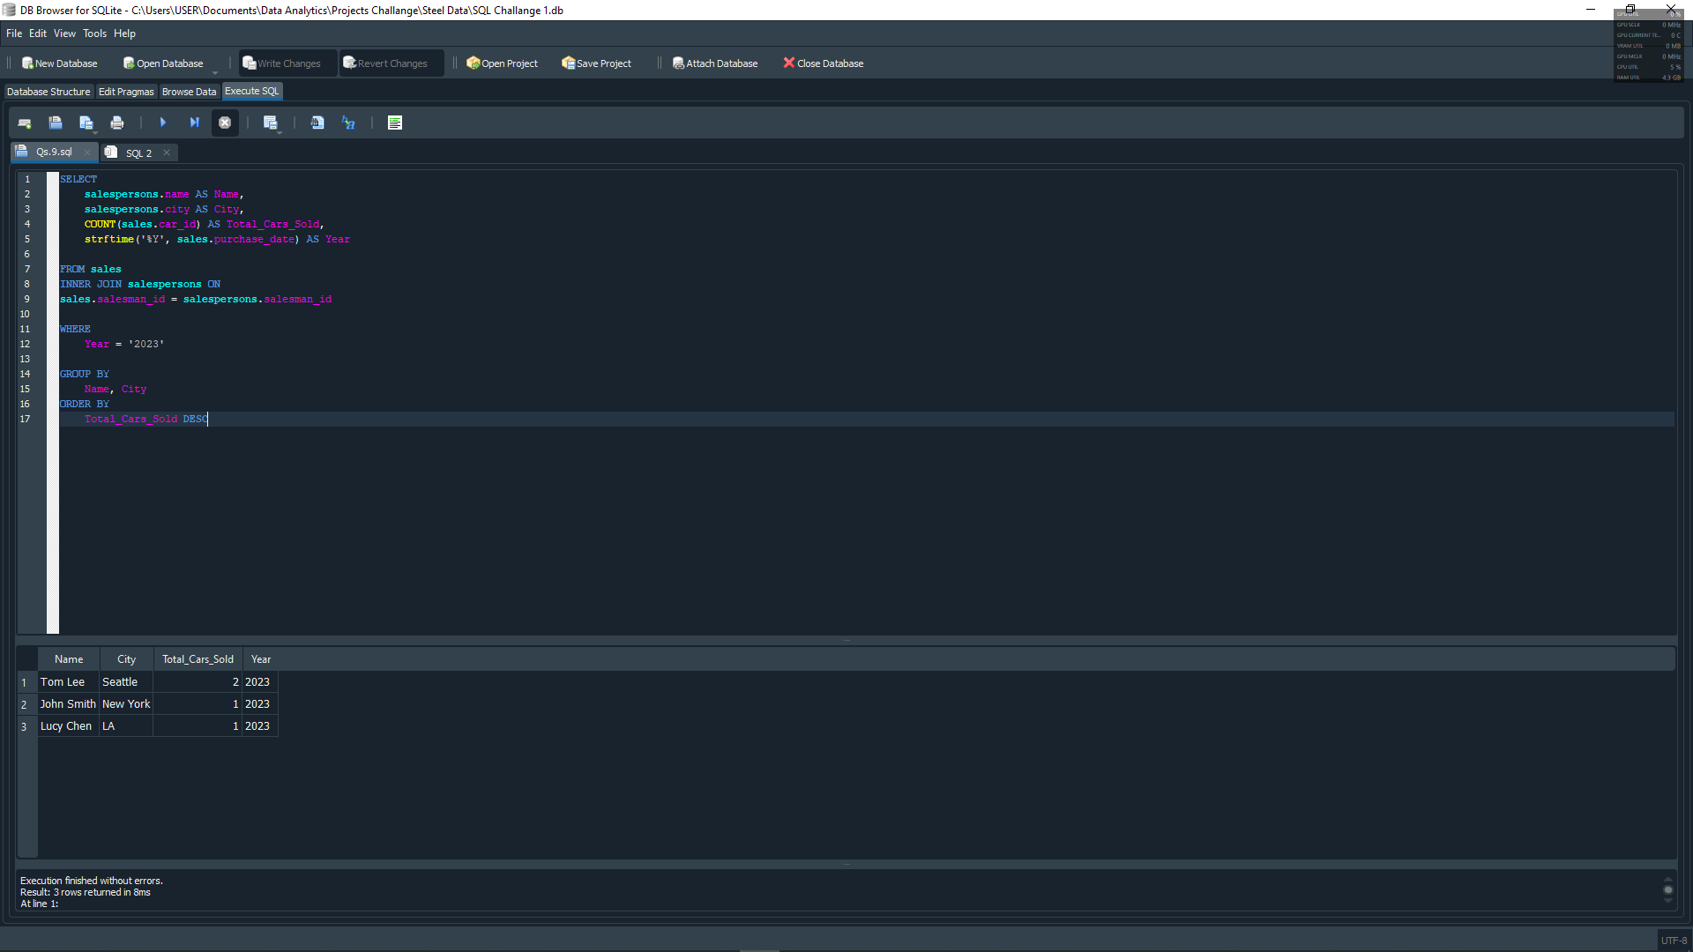

# **QUESTION 10: WHAT IS THE NAME AND AGE OF THE SALESPERSON WHO GENERATED THE HIGHEST REVENUE IN THE YEAR 2022?**

